# Homework 3 – Rui Qin 30874157 Studio 25 Mon 18:00 Ashwini Narasimha

[A2/week9hw.html at master · 2XUID/A2 (github.com)](https://github.com/2XUID/A2/blob/master/week9hw.html)

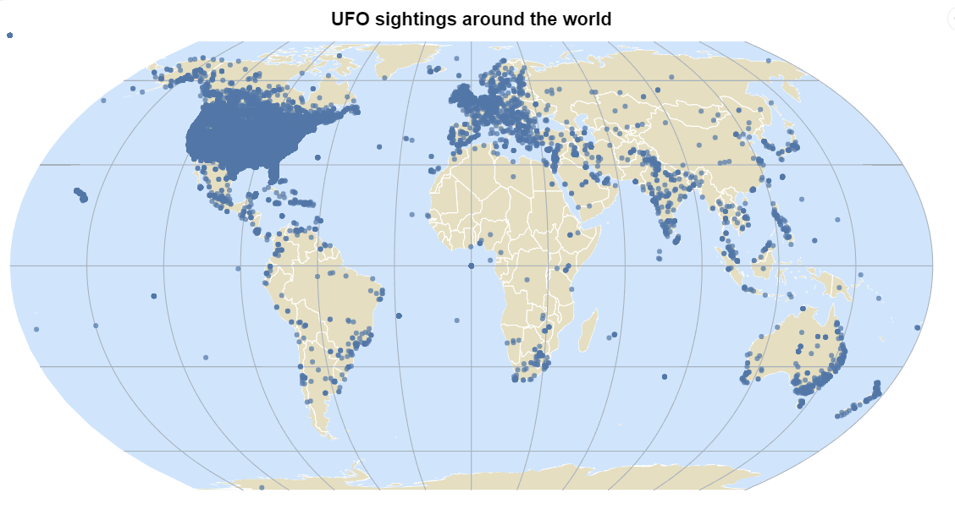

* Domain of the visualisation: UFO sightings around the world
* Visualised dataset:
  + Attribute types: datetime, city, state, country, shape, duration (seconds), duration (hours/min), comments, date posted, latitude, longitude
  + Source: National UFO Reporting Center (NUFORC)
  + Author: National UFO Reporting Center (NUFORC)
  + Link: [UFO Sightings | Kaggle](https://www.kaggle.com/datasets/NUFORC/ufo-sightings)
* Data transformation: None
* Justification for the type of map idiom used: I chose to create a symbol map because it is a good way to visualize quantitative data that is distributed over a large area. The concentration of the symbol represents the number of UFO sightings in each location, making it easy to see where there are high and low concentrations of sightings.